URL: https://adityabirlahospital.com/blogs/why-heart-attacks-increasing-in-young-indians
Meta Title: Why are Heart Attacks Increasing in Young Indians | Aditya Birla Memorial Hospital

Meta Description: Heart attacks are rising among young Indians. Learn the causes, risk factors, warning signs, and prevention tips to protect your heart health early.

H1: Why are Heart Attacks Increasing in Young Indians
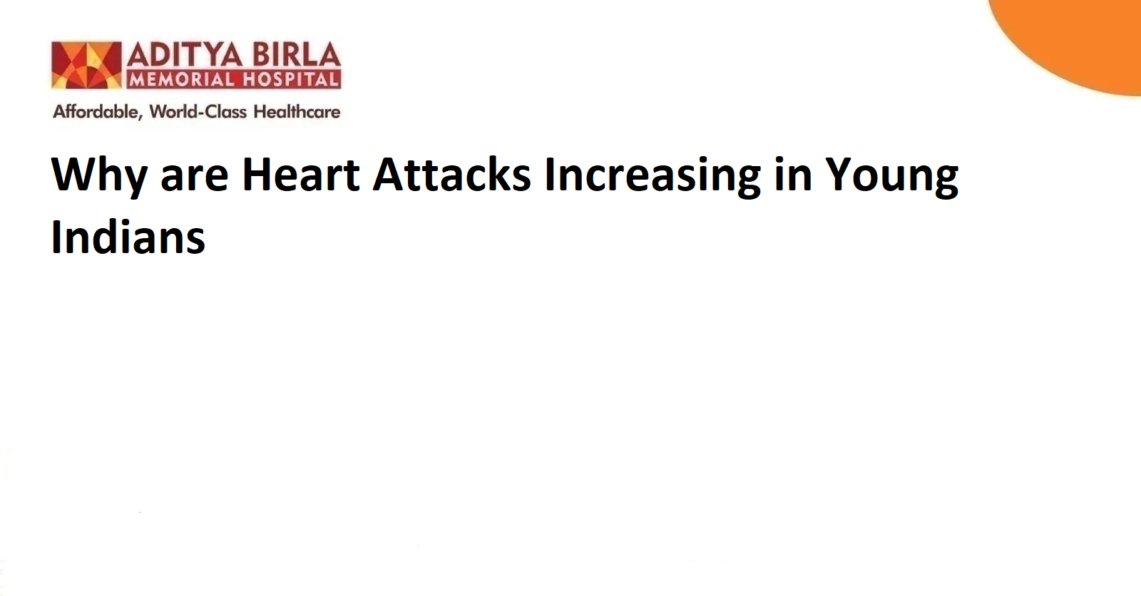

Heart disease has always been a concern among older adults. That perception is now changing. More young individuals are visiting emergency departments with symptoms of chest tightness, fatigue, and irregular heart rate. While this rise has been noted worldwide, the pattern seems more pronounced among Indian men and women under the age of 45. Understanding the reason for a heart attack at a young age is the first step in preventing life-altering outcomes later.

The symptoms often mimic general fatigue or stress. The causes, on the other hand, are linked to deeper metabolic, lifestyle, and behavioural shifts. When not addressed early, these can slowly affect heart function and trigger cardiac events. As newer data from Indian healthcare settings shows, the need to intervene early has become more important than ever.

The Symptoms and Causes of Heart Diseases:

A. The Symptoms
Symptoms of heart attacks in young adults may not follow the typical pattern seen in older patients. Most individuals report vague complaints before they reach hospital settings. Understanding these early signs may help reduce the delay in treatment.

- Tightness in the chest or unusual pressure around the sternum is one of the most common symptoms of a heart attack at a young age in India.
- Sudden fatigue or tiredness after minor physical activity may point towards underlying heart disease.
- Dizziness or a feeling of lightheadedness may be linked to sudden changes in heart rate or blood pressure.
- Pain spreading from the chest to the left shoulder, neck, or jaw is often a serious sign of cardiac strain.

In some cases, palpitations or skipped beats may also be reported. While most individuals dismiss these symptoms as stress-related, they may represent an underlying cardiovascular issue.

B. The Causes
The cause of a heart attack at a young age may often appear behavioural but is deeply connected to physiological imbalance.

- Stress continues to be one of the leading triggers. Chronic emotional strain increases cortisol production, which may result in high blood pressure along with heart rhythm disorders.
- Sedentary routines often delay fat metabolism and insulin regulation. Both of these can increase cholesterol levels, leading to plaque formation in arteries.
- High intake of processed food and low fibre diets may result in early-onset obesity and high triglycerides, especially in urban Indian populations.
- Smoking along with occasional alcohol use in social settings may damage the inner lining of arteries and restrict oxygen flow.
- Unregulated use of supplements or steroids by fitness enthusiasts has also shown an impact on vascular inflammation and clotting.

When understood together, these factors answer the common question, i.e., what causes heart attacks in young people today?

Why Heart Problems Are Becoming Common Among Young People:
The increase in heart attack cases in younger age groups cannot be seen in isolation. It has emerged as a lifestyle pattern in Tier 1 and Tier 2 cities across India. The changes have been gradual, but their cumulative impact is now becoming visible in clinical practice.

Unlike previous decades, many Indian youth today experience high exposure to work-related pressure at an early age. The resulting lack of sleep and stress accumulation may contribute to vascular inflammation. In many cases, this may remain undetected until a major event occurs.

Another cause of heart attack at a young age is poor food quality. Processed snacks, soft drinks, and preserved meals have replaced home-cooked food in many urban centres. This leads to a higher carbohydrate load and irregular blood sugar levels. When combined with reduced physical activity, these become key contributors to the risk.

The rise of digital habits has further replaced regular playtime and outdoor movement. Long hours spent in front of screens may reduce natural circulation, which is essential for a healthy heart rate and blood pressure regulation.

Medical experts have also pointed out a new concern. Many young adults ignore health check-ups and cholesterol screening, believing that such conditions only affect older people. This delay in detection may lead to higher chances of plaque build-up and sudden heart blockages.

Managing and Limiting the Chances of a Heart Attack:
Lifestyle correction remains the most practical solution for those looking to reduce cardiac risk. While not every factor may be controllable, many early-stage triggers can be reversed with the right steps.

- Regular physical activity for at least 30 minutes each day may help improve blood flow and reduce blood pressure.
- Heart-healthy diets with fibre-rich foods along with fruits and low-oil preparations may support better cholesterol management.
- Hydration along with controlled salt intake may reduce the chance of bloating and elevated blood pressure during stressful situations.
- Reducing smoking and alcohol exposure may allow the arteries to heal and regain their normal elasticity over time.
- Managing weight with sustainable goals and balanced exercise plans may reduce the load on the heart during physical activity.
- Screening tests for heart rate variability, cholesterol levels, and blood sugar must begin early [especially in individuals with a family history].

Medical supervision must be sought immediately when someone experiences prolonged discomfort, unexpected tiredness, or unusual changes in heart rate. Young adults must also be encouraged to seek advice from the best cardiologists in Pimpri-Chinchwad or visit the best cardiology hospital in Pimpri-Chinchwad for expert guidance, if symptoms persist.

Conclusion:
Understanding why a heart attack happens at a young age is essential for protecting the next generation from preventable cardiac risks. The cause of a heart attack at a young age in India has less to do with age itself and more to do with daily habits, stress levels, and delayed detection. The good news is that these patterns can be reversed through diet, exercise, and timely checks. It is never too early to start caring for your heart.

FAQs

Has heart attack increased since COVID?
Yes. Clinical data shows a higher number of heart attack cases in younger individuals after COVID-19. This may be due to long-term inflammation and the lingering effects of the infection on blood vessels.

Can diet reverse heart disease?
Diet may play an important role in managing cholesterol levels along with blood sugar and weight. A consistent food plan with fresh ingredients may help reverse certain early-stage heart conditions under medical supervision.

Can exercise prevent heart attacks?
Exercise helps regulate blood pressure along with heart rate and circulation. When practised regularly, physical activity may improve heart health and reduce the risk of cardiac events in both young and older adults.

Is heart disease preventable?
Yes. Most types of heart disease are preventable when risk factors are identified early. Lifestyle choices, regular health checks, and stress management are often enough to reduce the overall burden of heart disease in young adults.

References:

https://drsaritaraocardiologist.com/why-heart-problems-are-rising-among-young-indians-insights-by-dr-sarita-rao/

https://pmc.ncbi.nlm.nih.gov/articles/PMC12060909/

